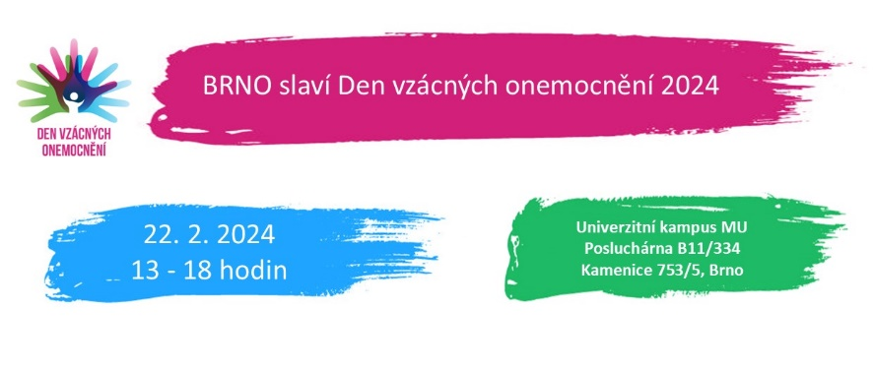

**The end of February is Rare Disease Day worldwide. Even diseases that are rare deserve attention. That is why the MU Faculty of Medicine is dedicating a free seminar for the general public, experts and families of patients to them.**

The topic of rare diseases has come up quite often recently. This is also due to the fact that the term "rare" can be somewhat misleading. It refers to uncommon diseases affecting less than 1 in 2 000 people. However, the total number of such diseases is more than 6 000, and thanks to improving diagnostics, the number is constantly increasing. In the Czech Republic, the number of patients is more than half a million, and 300 million worldwide. And many more are still waiting to be diagnosed. Rare diseases are mostly hereditary and affect the whole organism. They have a significant impact on a patient's quality of life or directly threaten it.

Rare Disease Day falls on the last day of February and always follows a common theme. For this leap year, it is: For More Rare Moments and symbolizes the effort to increase access and quality of care. "In recent years, therapies have brought great hope for many patients," explains Renata Gailly, a clinical geneticist who has long been involved in the topic of rare diseases. "I am pleased that this positive dimension is also reflected in the Rare Disease Day seminar in Brno," adds Gaillyová, the event's main coordinator.

The seminar will take place on Thursday, 22 February at the premises of the MU Faculty of Medicine campus.

It is jointly organised by the Institute of Medical Genetics and Genomics of the MU Faculty of Medicine and the University Hospital Brno together with the Czech Association for Rare Diseases (CAVO), the National Coordination Centre for Rare Diseases at the Motol University Hospital and the MU Faculty of Medicine CREATIC Centre of Excellence.

The individual sessions will cover, for example, the diagnosis of rare diseases, patient care and hereditary predisposition to hematopoietic cancers. Anna Arellanesová, the founder and chairwoman of CAVO, as well as representatives from the Ostrava and Olomouc hospitals will speak.

Prof. Petr Štourač from the Brno University Hospital will present more than 20 years of activity of the Centre for Malignant Hyperthermia and Dr. Kateřina Slabá will present the outpatient clinic for undiagnosed paediatric patients. A patient with SMA will talk about the rare disease as one of the circumstances of life.

The program also includes an exhibition that is located in the campus hallway throughout February. It was created by the Gene Therapy Association (Asgent) and aims to promote the topic of rare diseases and the availability of cell and gene therapies. Representatives from Asgent will also speak at the program with a keynote on the importance of PR for patient organizations.

The event will conclude with a workshop on Patient Engagement in Clinical Trials, prepared by the CREATIC Centre of Excellence. The workshop will be conducted by Dr. Lenka Součková, who is the European correspondent of the ECRIN network. She will explain how to navigate through clinical trial registries and the specifics of studies focused on rare diseases and modern therapies. The CREATIC Centre at the MU Faculty of Medicine will deal with their development and production.

logo Masarykova univerzita – Lékařská fakulta 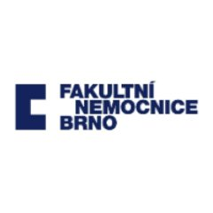 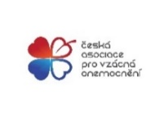 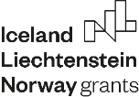 

Supported by Iceland, Liechtenstein and Norway through the EEA Funds, reg.no. ZD-ZDOVA2-001The CREATIC Centre of Excellence is funded by the European Union under the Horizon Europe Programme on the basis of a Grant Agreement 101059788.

